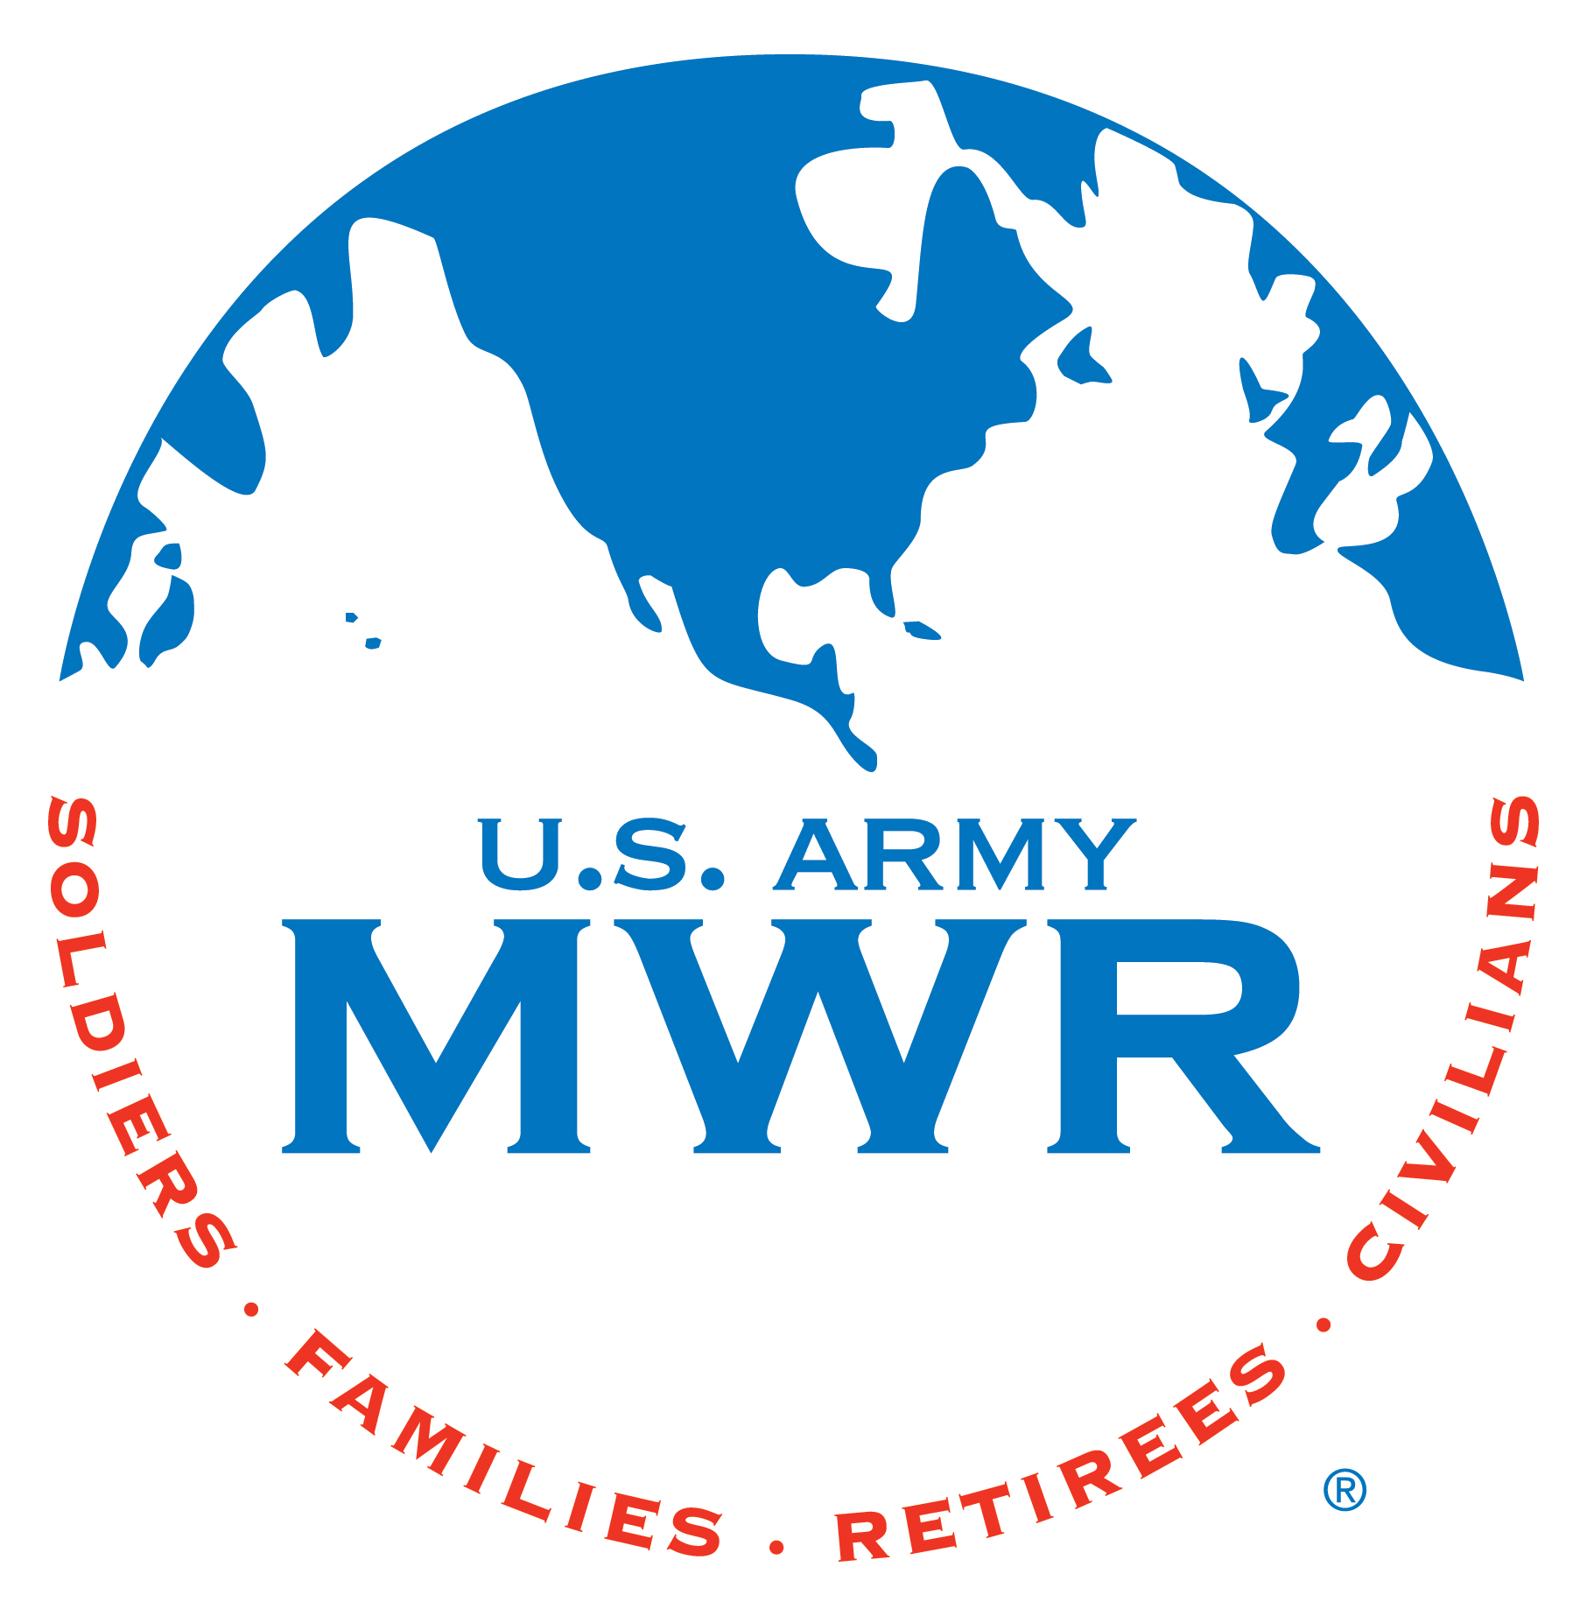
BOSS Installation Meeting
00 Month 0000
254-287-6116

BOSS LOUNGE HRS: 1130-1700 Weekdays
Closed on weekends and Holidays

No endorsement implied

Meeting called to order at 1300, Roll call and administrative notes,
Opening Remarks
OLD BUSINESS:

Quality of Life:

Community Service (All Volunteer Opportunities 2X Hrs)

Recreation and Leisure
Next 30/60 Days

NEW BUSINESS: (OPEN THE FLOOR)
REMINDERS
- Next BOSS Instillation meeting: 00 MONTH, 1300hrs at the BOSS HQ
- Continuously update ALL BOSS Boards, Barracks BOSS boards and DFACs with new calendars/flyers
“That Guy” Inquiries POC SPC Davis/SPC Martinez (Material still available)
Continue Rep awareness and communication to their commands
Wednesday
Thursday
Friday
Saturday
Tuesdays
Monday
Sunday
 |  |  | MONTH 2017 Calendar
 |  | 1 | 2 | 3 | 4 | 5
6 | 7 | 8 | 9 | 10 | 11 | 12
13 | 14 | 15 | 16 | 17 | 18 | 19
20 | 21 | 22 | 23 | 24 | 25 | 26
27 | 28 | 29 | 30 | 31

